Software Requirements Specification (SRS)

Office ERP System – Employee Management System

Prepared by Shivam Chaturvedi
Team Delta
Table of Contents
Table of Contents ii
Revision History ii
1. Introduction 1
1.1 Purpose 1
1.2 Document Conventions 1
1.3 Intended Audience and Reading Suggestions 1
1.4 Project Scope 1
1.5 References 1
2. Overall Description 2
2.1 Product Perspective 2
2.2 Product Features 2
2.3 User Classes and Characteristics 2
2.4 Operating Environment 2
2.5 Design and Implementation Constraints 2
2.6 User Documentation 2
2.7 Assumptions and Dependencies 3
3. System Features 3
3.1 System Feature 1 3
3.2 System Feature 2 (and so on) 4
4. External Interface Requirements 4
4.1 User Interfaces 4
4.2 Hardware Interfaces 4
4.3 Software Interfaces 4
4.4 Communications Interfaces 4
5. Other Nonfunctional Requirements 5
5.1 Performance Requirements 5
5.2 Safety Requirements 5
5.3 Security Requirements 5
5.4 Software Quality Attributes 5
6. Other Requirements 5
Appendix A: Glossary 5
Appendix B: Analysis Models 6

Introduction

Purpose
The purpose of this Software Requirements Specification (SRS) document is to detail the functional and non-functional requirements for the development of an Office Enterprise Resource Planning (ERP) system. This system aims to streamline and integrate various office operations, including human resources, finance, inventory, and project management, into a unified platform to enhance efficiency and decision-making processes.

Document Conventions
- · Terminology: All technical terms and acronyms are defined in the Glossary section.
- · Formatting:
- Bold: Used for section headings and important terms.
- Italics: Used for emphasis and document references.
- Monospace: Used for code snippets and system commands.
- · References: Citations are provided in square brackets.

Intended Audience and Reading Suggestions
- Project Stakeholders: To understand the system's capabilities and limitations.
- Development Team: To guide the design, development, and implementation phases.
- Quality Assurance Team: To develop test plans and ensure the system meets specified requirements.
- End Users: To gain an overview of the system's functionalities and usage.
- Reading Suggestions:
- Stakeholders should focus on Sections 1 and 2 for an overview.
- Developers should thoroughly review Sections 3 and 4 for detailed requirements.
- QA personnel should concentrate on Sections 5 and 6 for testing criteria.

Project Scope
The Office ERP system will encompass the following modules:
- Human Resources Management: Employee records, attendance, leave management, and payroll.
- Financial Management: Budgeting, accounting, and expense tracking.
- Inventory Management: Stock control, procurement, and supplier management.
- Project Management: Task assignment, progress tracking, and resource allocation.
- Reporting and Analytics: Customizable reports and dashboards for informed decision-making.

References
ERPNext GitHub Repository: https://github.com/frappe/erpnext
IEEE Std 830-1998, IEEE Recommended Practice for Software Requirements Specifications.
ISO/IEC/IEEE 29148:2018, Systems and software engineering — Life cycle processes — Requirements engineering

Overall Description

Product Perspective
The Office ERP system is a modular, web-based application that integrates key office operations into a single digital platform. It is intended to replace isolated software tools used for HR, finance, inventory, and project management with a unified system. The product will be built using a MERN stack (MongoDB, Express.js, React.js, Node.js), making it scalable and suitable for both small and mid-sized businesses.

Product Features
Human Resource Management (HRM)
- Employee records
- Attendance and leave tracking
- Payroll automation
Finance Module
  - Expense tracking and reporting
  - Budget management
  - Invoice generation and payment logs
Project Management
  - Task assignment and tracking
  - Team collaboration tools
  - Gantt charts and progress reports
Authentication and Role-Based Access
  - Admin, Manager, and Employee roles
  - Secure login with JWT
  - Reporting and Dashboard
  - Customizable dashboards
  - PDF/Excel report export
  - KPI metrics and analytics

User Classes and Characteristics
Administrator:
- Full access to all modules
- Manage user roles, system configuration
HR Manager:
- Access to HR, payroll, and attendance
- Limited access to reporting
Finance Officer:
- Access to accounting and expense modules
Project Manager:
- Access to projects, tasks, and team management
Employee:
- View personal records, apply leaves, view assigned tasks

Operating Environment
Client Side:
- Compatible with modern browsers (Chrome, Firefox, Edge)
- Responsive design for mobile and desktop using React Js.
Server Side:
- Node.js with Express for backend
- MongoDB as the database
- Deployed on cloud platforms like Render, Vercel, or AWS.

Design and Implementation Constraints
The system is developed using MongoDB, which, while offering flexibility, limits the ability to enforce strict relational schema designs. The architecture must follow RESTful API principles, and JWT-based authentication must be implemented securely to prevent vulnerabilities. Additionally, the system must remain within resource constraints of the hosting environment, especially in cases where free or budget cloud hosting services like Render are used. All external libraries and packages must be open-source and licensed appropriately, preferably under the MIT or similar license.

User Documentation
Comprehensive documentation will be provided to assist all users. A general user manual will be created for employees and department heads to understand the system's usage. An admin guide will include detailed instructions for system setup, user management, and configuration options. Technical documentation for the API will be auto-generated using tools such as Swagger or Postman. Optional video tutorials will also be made available to simplify the onboarding process for new users.

Assumptions and Dependencies
The system assumes users will have basic digital literacy and access to stable internet connections. It is also dependent on the availability of technologies like Node.js (LTS version) and MongoDB (latest stable release). External packages such as Mongoose for data modeling, React-Bootstrap for frontend components, and Chart.js for visual reports will be used. Additionally, integration with third-party services for email and SMS notifications (like SendGrid or Twilio) is expected to be reliable and configurable.

System Features

Human Resource Management
3.1.1 Description and Priority

This module handles employee information, attendance, leaves, and payroll. It is of High priority, as accurate HR data is crucial for operations and compliance.

Benefit: 9 Penalty: 8 Cost: 5 Risk: 4
3.1.2 Stimulus/Response Sequences
- The HR manager logs in → navigates to the employee management page → adds or updates employee records → system validates data and updates MongoDB.
- Employee requests leave → system records the request → manager approves/rejects → system updates leave status and notifies the employee.
- Attendance is auto-marked daily or manually entered → payroll is calculated monthly → system generates salary slips.
3.1.3 Functional Requirements
- REQ-HR-1: The system shall allow HR to create, view, edit, and delete employee records.
- REQ-HR-2: The system shall support uploading employee documents and profile pictures.
- REQ-HR-3: The system shall allow employees to request leave and view approval status.
- REQ-HR-4: The system shall notify HR on pending leave requests.
- REQ-HR-5: The system shall automatically calculate salaries based on attendance and predefined salary rules.
- REQ-HR-6: The system shall generate monthly payroll reports and individual salary slips in PDF format.
- REQ-HR-7: The system shall handle invalid inputs such as overlapping leave dates or negative salary figures with proper error messages.

Finance and Accounting

3.2.1 Description and Priority

Manages the tracking of expenses, budget allocation, and invoice management. This is also a High priority feature.
Benefit: 9 Penalty: 7 Cost: 6 Risk: 3

3.2.2 Stimulus/Response Sequences
- Finance officer logs in → adds new expenses → system validates data → updates finance records.
- Manager generates a report → system filters records by date/project and exports report.

3.2.3 Functional Requirements
- REQ-FIN-1: The system shall allow adding, editing, and deleting expense entries.
- REQ-FIN-2: The system shall auto-categorize expenses by department or project.
- REQ-FIN-3: The system shall support uploading receipts or invoice documents.
- REQ-FIN-4: The system shall generate monthly or custom-date financial reports.
- REQ-FIN-5: The system shall export reports to PDF and Excel formats.
- REQ-FIN-6: The system shall validate that required fields (amount, date, type) are filled.
- REQ-FIN-7: The system shall prevent duplicate invoice generation using unique invoice IDs.

Project Management

3.3.1 Description and Priority

This module enables planning and tracking of projects, tasks, teams, and deadlines. It is of Medium to High priority, depending on the company’s project load.
Benefit: 8 Penalty: 6 Cost: 4 Risk: 4

3.3.2 Stimulus/Response Sequences
- Project manager creates a new project → system stores project info and assigns a unique ID.
- Manager assigns tasks to employees → system updates employee dashboards.
- Employees mark tasks complete → system updates project progress chart.
3.3.3 Functional Requirements
- REQ-PM-1: The system shall allow creation and assignment of tasks under each project.
- REQ-PM-2: The system shall support deadline setting and status tracking (To Do, In Progress, Done).
- REQ-PM-3: The system shall allow comments or updates under each task for team collaboration.
- REQ-PM-4: The system shall display progress using Gantt or bar charts.
- REQ-PM-5: The system shall notify users of deadlines via email/SMS (via 3rd-party APIs).
- REQ-PM-6: The system shall allow managers to reassign or cancel tasks.
- REQ-PM-7: The system shall handle input validation for dates, task names, and project overlaps.

Authentication and Access Control

3.4.1 Description and Priority

Secures the system using login credentials and enforces access rights based on user roles. This is a High priority feature.
Benefit: 9 Penalty: 9 Cost: 4 Risk: 6

3.4.2 Stimulus/Response Sequences
- User opens login page → submits credentials → system authenticates via JWT → redirects to dashboard based on role.
3.4.3 Functional Requirements
- REQ-AUTH-1: The system shall provide login and logout functionality for all users.
- REQ-AUTH-2: The system shall encrypt passwords and validate users via JWT tokens.
- REQ-AUTH-3: The system shall redirect users to their respective dashboards (Admin, Manager, Employee).
- REQ-AUTH-4: The system shall restrict access to unauthorized modules.
- REQ-AUTH-5: The system shall invalidate sessions after logout or inactivity timeout.
- REQ-AUTH-6: The system shall log failed login attempts for security audit.

External Interface Requirements

User Interfaces
The Office ERP system will offer a modern and responsive web-based GUI built with React.js. It will follow a consistent design language, using a component library like React-Bootstrap or Material UI for visual uniformity and usability.
Each user interface will be tailored to user roles (Admin, HR Manager, Employee, etc.) and include:
- Top navigation bar for quick access to modules (HR, Finance, Projects, etc.)
- Sidebars with collapsible menus for sub-functions (e.g., "Payroll" under HR)
- Form validation and error messages for incorrect inputs
- Toast notifications for success/warning/error states
- Dark mode (optional feature)
- Consistent placement of buttons like Submit, Cancel, and Edit
- Responsive design to support mobile, tablet, and desktop
- Keyboard navigation where applicable for accessibility

Hardware Interfaces
Since this is a web-based system, no specialized hardware interfaces are required. However, the system will support:
- Client Devices: PCs, laptops, tablets, and mobile phones with modern web browsers
- Server Requirements:
- CPU: Minimum dual-core (e.g., 2.0 GHz)
- RAM: Minimum 4 GB (Recommended: 8 GB)
- Storage: SSD recommended (for fast read/write of logs and documents)
- Peripherals: For HR/admin use, standard printers may be used for reports/salary slips

Software Interfaces
The system will interact with various internal and external software components:

Backend and Database
- Node.js (v18 LTS) – Backend server runtime
- Express.js – RESTful API framework
- MongoDB (v6.x) – NoSQL document-based database
- Mongoose ORM – For schema definitions and queries

Data Exchange
- JSON format will be used for all API communications
- REST APIs will follow standard HTTP verbs (GET, POST, PUT, DELETE)
- API authentication will use JWT tokens passed in HTTP headers

Other Tools/Libraries
- Chart.js – Used for displaying KPI graphs
- React Router – SPA navigation
- Context API– For state management across the app

Communications Interfaces
The Office ERP system will require stable internet connectivity and use standard web protocols:
- HTTP/HTTPS for secure browser-server communication
- TLS encryption for all sensitive data in transit
- JWT tokens for session management and API authentication
- SMTP (via SendGrid) for email delivery

Other Nonfunctional Requirements

Performance Requirements
- The system must support up to 500 concurrent users without noticeable lag.
- API response times should be under 500ms for 95% of requests.
- Attendance sync from IoT devices should reflect in the system within 5 seconds.
- Dashboard analytics must load in under 2 seconds with pre-aggregated data.

Safety Requirements
- The system must prevent data loss by enabling automated daily backups.
- Admin actions like payroll processing or user deletion should have confirmation prompts.
- Role-based access must restrict unauthorized access to sensitive data.
- Future IoT devices must be protected with voltage/current limits and fallback shutdowns.

Security Requirements
- All user data must be stored securely using encryption at rest and in transit (HTTPS, TLS).
- Authentication must use JWT tokens with expiry and refresh logic.
- Passwords must be hashed (e.g., bcrypt) before storage.
- Two-factor authentication (2FA) will be added in future releases.
- Admin access will be logged with IP and time-stamped audit trails.

Software Quality Attributes
- Usability: The UI must be intuitive for all user roles with minimal training.
- Reliability: System uptime target is 99.9% monthly.
- Maintainability: Modular codebase using MVC structure with clear documentation
- Scalability: Easily deployable on cloud (e.g., Render, AWS) to handle increased load.
- Portability: App must run on any OS with Node.js and MongoDB.
- Interoperability: APIs designed to allow integration with external systems like accounting tools.

Other Requirements
- Database Requirements:
The system will use MongoDB for primary data storage. Collections will be defined for employees, projects, payroll, inventory, attendance, etc. Indexing and normalization practices will be used for performance optimization.
- Internationalization Requirements:
The UI will initially support English, with future support for localization using libraries like react-i18next.
- Legal Requirements:
The system must comply with local labor laws regarding payroll, leave, and employee data protection (e.g., GDPR or India’s IT Act where applicable).
- Reuse Objectives:
Components like authentication, dashboard widgets, and reporting modules are to be designed as reusable components for potential integration into other company systems.
- Mobile Extension:
In future, a mobile app will be developed to mirror core functionalities (attendance, leave application, task viewing) using React Native.
Appendix A: Glossary
Term | Definition
ERP | Enterprise Resource Planning – software to manage core business processes
MERN | Stack comprising MongoDB, Express.js, React.js, Node.js
JWT | JSON Web Token – used for secure authentication
IoT | Internet of Things – hardware devices like sensors and scanners
HRM | Human Resource Management
API | Application Programming Interface
UI/UX | User Interface / User Experience
Appendix B: Analysis Models

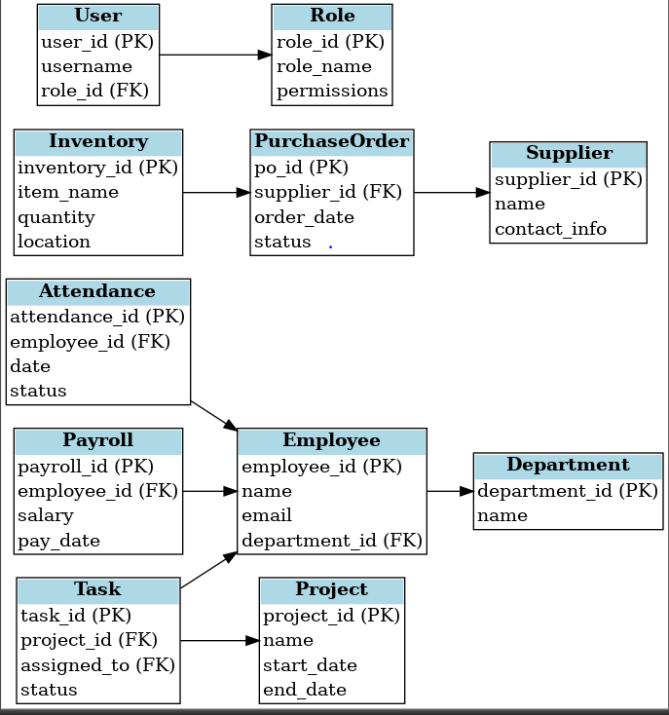
Figure 6.1 : ER -DIAGRAM FOR OFFICE ERP SYSTEM

